# **Risk Management for Power Supply 1A1**

This is a contingency plan for power supply 1A1 in figure 1 that provides regulated power for both the controller 2U5 and the lighting strip 2U1. The maximum power point tracker (MPPT) 1U1 converts energy from the solar panel 1BT1 and battery 1BT2 into voltage-regulated 12 VDC output power. However, a separate power supply will be required to produce a voltage-regulated 7.1 VDC 7.1 W power source for controller assembly 2U5, and a 10 VDC 60 W power source for lighting strip assembly 2U1. We determined this to be a primary risk element since it is required for powering all of Unit 2 and is a dual output power supply.

## Plan B

Since the numbers above are specific to the project and are mainly to minimize power consumption from the battery, if we cannot construct a working power supply by February 19, 2021, we plan to purchase a dual output supply as a replacement. Our goal is to have the purchased supply arrive by February 26, 2021 for the last week of development. Unit 1 can function without the power supply, and Unit 2 is testable using DC power supplies in the lab until we get this one working. Purchasing a DC to DC dual output power supply that supports the appropriate currents and voltages would be outside the $500.00 budget for our group. Purchasing two buck/boost converters would cost between $40.00 and $60.00 plus $5.00 shipping and connecting them to the MPPT output will require one week at most. Our goal to complete this is March 5, 2021.

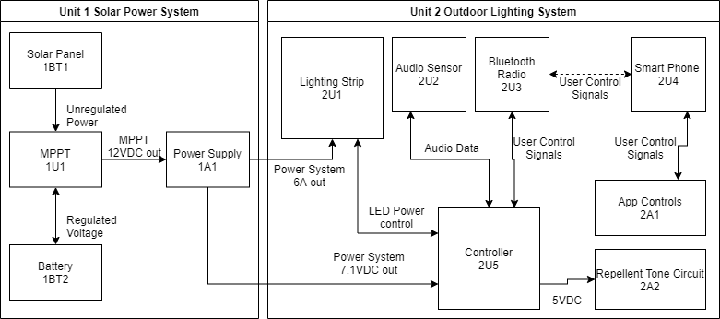

Figure 1. Functional block diagram.